1. **Implementation of Temporal Memory Parallel Version**
   1. Code for Inner Loop to be populated in the inner columns

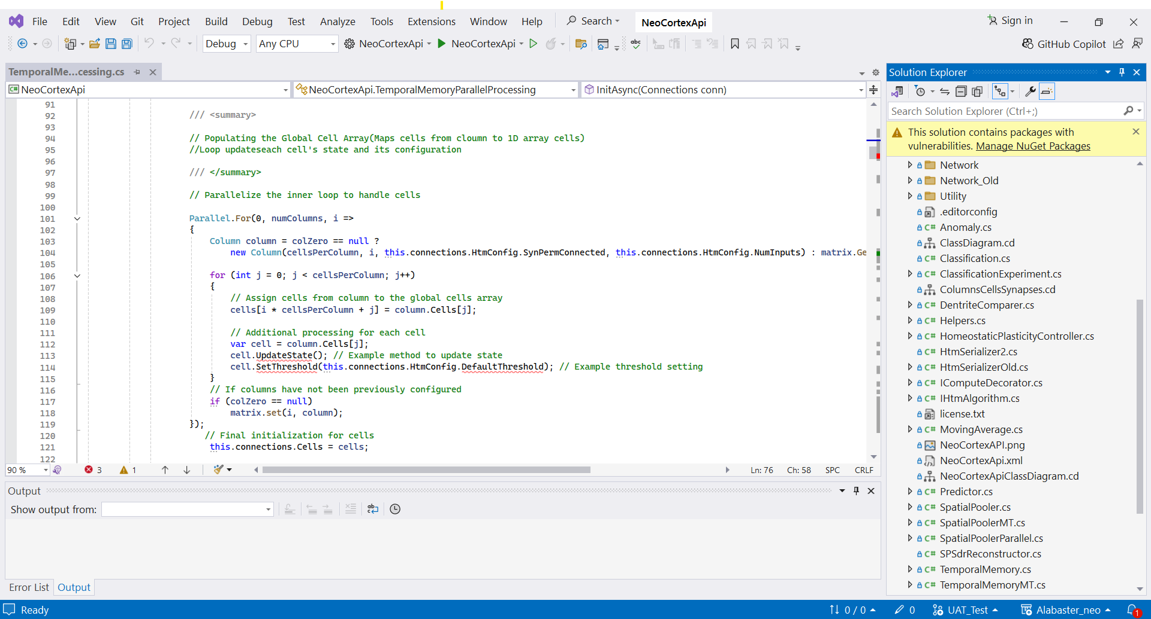

* 1. inner loop is written to initialize the cells of the current column efficiently, using parallel processing

